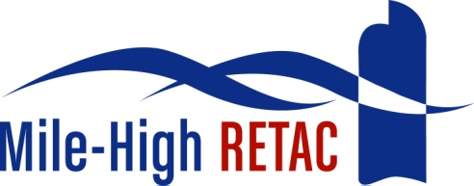

Mile-High Regional Emergency Medical and Trauma Advisory Council (MHRETAC)
National EMS Safety Summit
Embassy Suites Denver Downtown Convention Center
August 29-31, 2018
Course Scholarship Request
for Colorado Residents
Please complete and return to Shirley Terry, Executive Director, MHRETAC at shirleyterry@comcast.net
Date of Request: __________________
Name: _________________________________________________
Cell Number: ______________________________________
E-mail:__________________________________________________
Agency: ________________________________________________
Title: ___________________________________________________
RETAC:_________________________________________________
Have you attended the National EMS Safety Summit, during previous years?
Yes ____ What years? _____________No_____ Comments?
________________________________________________________________________________________________________________________________________________________________________________________________________________________________________________________________________________________
Please provide a brief financial need statement:
________________________________________________________________________________________________________________________________________________________________________________________________________________________________________________________________________________________
How will your attendance at this conference benefit your agency and the citizens you serve?
________________________________________________________________________________________________________________________________________________________________________________________________________________________________________________________________________________________
Have you provided safety related educational offerings or activities in the past to your agency? Please identify
__________________________________________________________________________________________________________________________________________________________________________________________________________________

What types of safety related activities would you like to provide in your region? ________________________________________________________________________________________________________________________________________________________________________________________________________________________________________________________________________________________
Any additional comments?
__________________________________________________________________________________________________________________________________________________________________________________________________________________
Have you applied for a CREATE Grant for this conference? What was the outcome?
____________________________________________________________________
This scholarship may cover conference general registration, hotel reservations and parking that is limited to $44 per day.
Thank you for your interest and request to the MHRETAC for the National EMS Safety Summit. You will be notified by e-mail regarding your request.

