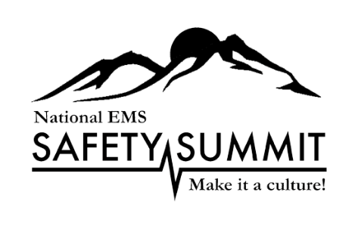

***National EMS Safety Summit***

***Bryan Fass Scholarship Request  
April 3-5, 2024***

**Request Deadline- March 15, 2024**

Please complete and return to Shirley Terry, Executive Director, MHRETAC Foundation at [sterry@nationalemssafetysummit.org](mailto:sterry@nationalemssafetysummit.org)

**Date of Request:**

**Name:**

**Cell Number:**

**E-mail:**

**Agency:**

**Title:**

**Have you attended the National EMS Safety Summit in the past?   
Yes**

**What years?**

**No**

**Comments?**

**Have you attended any safety related conferences?**

**Yes**

**No**

**Please identify the conference and when**

**Provide a brief financial need statement:**

**­­­­­­­­­­­­­­­­­­­How will your attendance at this conference benefit your agency and the citizens you serve?**

**Have you provided safety type educational offerings or activities in the past to your agency? Please identify**

**What types of safety related activities would you like to provide in your region?**

**Why is this conference important for you to attend?**

**Any additional comments?**

This scholarship will cover conference general registration only. Travel, lodging and the pre-conference registration is not covered in this scholarship.

Thank you for your interest and request to the National EMS Safety Summit. You will be notified by e-mail regarding your request.