***9th EMS Financial Symposium  
15th Annual National EMS Safety Summit***

***Embassy Suites by Hilton- Denver Downtown Convention Center  
1420 Stout St., Denver, Colorado 80202  
Crystal Ballroom***

***April 4-7, 2023***

***Exhibitor/Vendor Agreement***

**Contract of Agreement for Exhibitor/Vendor Space**

Company, Agency, or Organization:

On-site Authorized Representative(s) and Titles:

E-mail Address (s):

Cell Phone (s):

Office Address:

Office Phone:

City, State & Zip:

Vendor Information- limited to 75 words or less, you may e-mail this to Shirley Terry­­­­­­­­­­­­­­­­­­­­­­­­­

Please send the **company logo in word format** via e-mail to Shirley Terry by February 15, 2023.

**Electrical Needs:  
110- Yes_____ No ____ Electricity Rate is $50/ day.**Please indicate if you need more than one electrical outlet and bring extension cords.

This completed document indicates that the undersigned, representing the agency listed, requests the reservation of an exhibit space (s), which consists of a 3’ X 8’ table (draped and skirted) in a 10’ X 10’ booth with two chairs.

Please describe any exhibit materials and merchandise that the Exhibitor will place in the assigned space.

**Additional Representatives:**There is a fee of $200/day for more than two representatives on site.

The Exhibitor/Vender agrees to abide by the move-in and move-out times as specified by the Exhibitor/Vender Overview.

The EMS Financial Symposium, National EMS Safety Summit, MHRETAC Foundation or anyone associated with the MHRETAC Foundation is not responsible for damage from accident, theft of other such causes to Exhibitors/ Vendor’s property. The Exhibitor/Vendor is responsible for carrying any desired insurance at the Exhibitor/Vendor expense.

**Payments:**Payments must be received by **February 15, 2023**. For payment arrangements or questions please contact Shirley Terry. Checks or credit cards are accepted. Pay online or contact Shirley Terry for other options. **No REFUNDS after March 1, 2023.**

**Sponsorships:**Please see the Exhibitor/Vendor Overview for sponsorship opportunities. Sponsorships will allow both conferences to provide services and a more diverse curriculum to the EMS community. These sponsorships are invaluable and your participation in these conferences is much appreciated.

**Door Prizes:**Each year door prizes are awarded to those who stay the entire conference. Please bring some type of gift for a drawing. Thank you.

**Conference Bag Advertisement:**  
Full-page advertisements are available for $700 ($780 February 16 and after) and will be placed in the conference bags for all attendees. Please send it to Shirley Terry by February 15, 2023.

**Agreement Confirmation:**By submitting this agreement to Shirley Terry, you are agreeing to abide by the terms outlined above.

**For questions or concerns contact:**

Shirley Terry, BSN, RN  
Executive Director  
Mile-High RETAC Foundation  
2352 South Juniper Way  
Lakewood, Colorado 80228  
C- 303.919.0719  
[sterry@nationalemssafetysummit.org](mailto:sterry@nationalemssafetysummit.org)

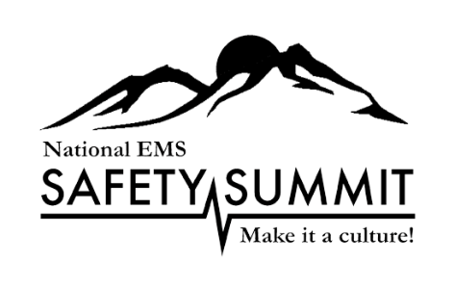

***Thank you for your support with these conferences.***

***Your support is greatly appreciated!***

***Mark your calendars for March 26-29, 2024!***