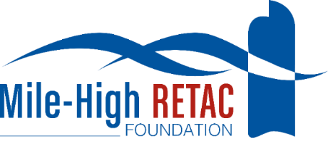 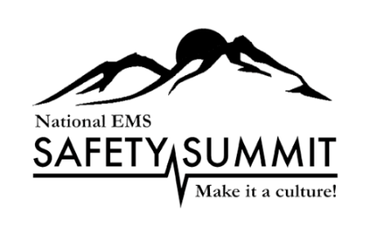

***Mile-High RETAC Foundation***

***Call for Speakers***

***11th EMS Financial Symposium, April 2, 2024***

***16th Annual National EMS Safety Summit April 3-5, 2024***

Please complete the following information and return to Shirley Terry at [sterry@nationalemssafetysummit.org](mailto:sterry@nationalemssafetysummit.org) by December 8, 2022. You may also contact me on my cell at 303.919.0719.

**Speaker Name**:

**Speaker Credentials:**

**Organization & Title:**

**Work Address:**

**City:**

**Cell Phone:**

**E-mail:**

**Title of Presentations:**#1-

#2-

**Length of Presentations:**

#1-

#2-

**Course Descriptions:**

#1-

#2-

**Learning Objectives:**

#1-

#2-

**Attendee Take-Away**In one sentence, what is the take-away for the attendees?

#1

#2

**Available Dates:**

**Requested Honorarium:**

**Projected Airfare:**

**Speaker Bio:**

**Speaker Photo:**

Please attach a photo that can be copied and pasted into a word document.

It is expected that each speaker will provide two presentations to assist with cost reduction. Shirley Terry will notify you of acceptance of this request.

Thank you for your interest in the EMS Financial Symposium, April 2, 2024, and the National EMS Safety Summit, April 3-5, 2024, both to be held at the Embassy Suites Downtown Denver.